1. **Testing the Login Screen**

**Making sure the login screen launches**

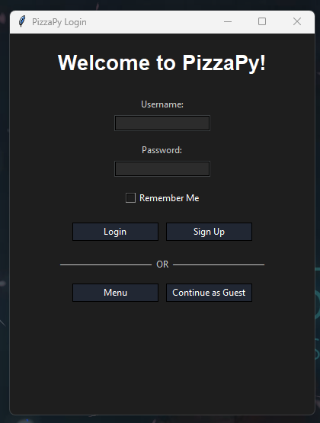

**Adding a new user**

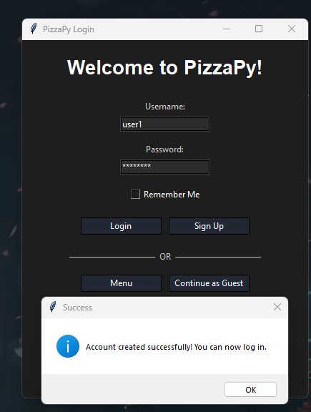

**Making sure the username cannot be used more than once**

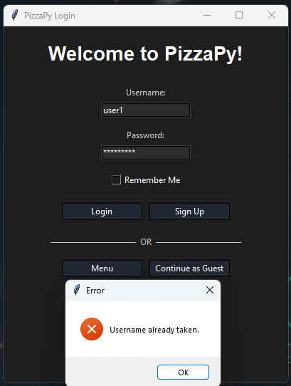

1. **Testing the Ordering Screen**

**Ordering a Margherita pizza**

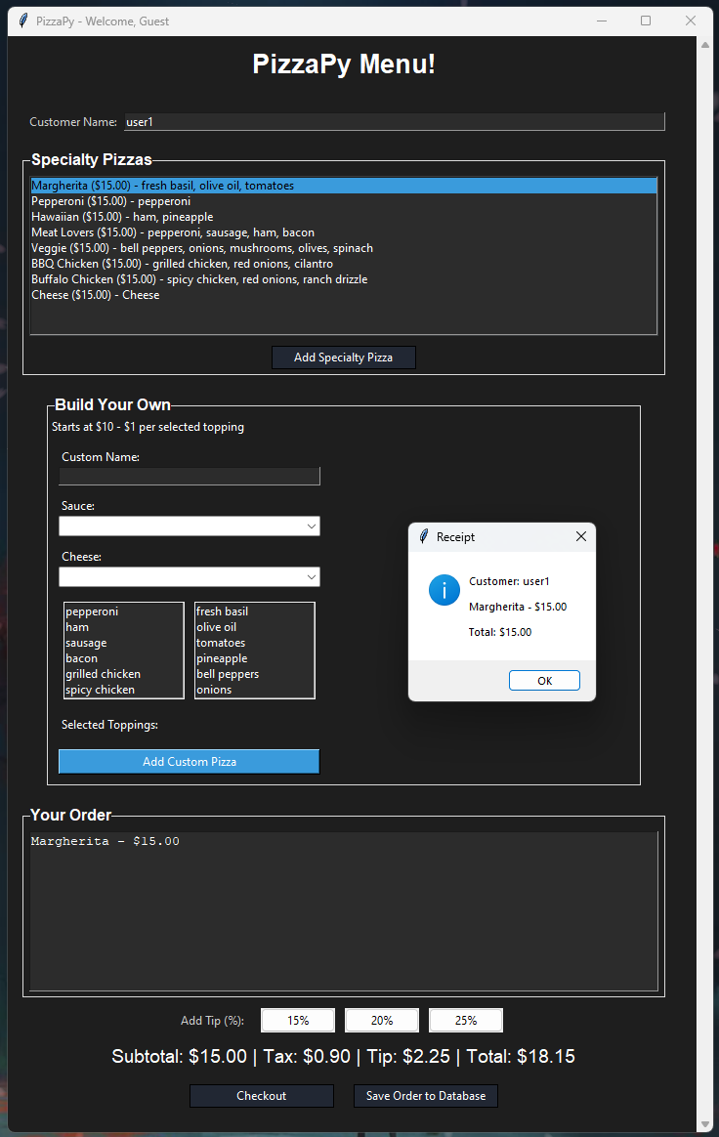

**Ordering a Pepperoni pizza**

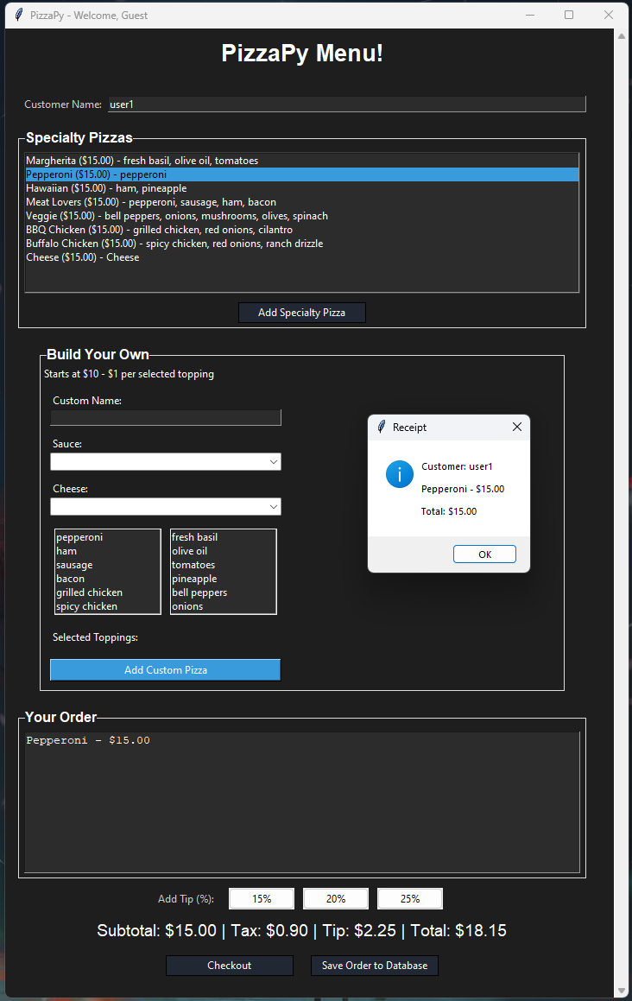

**Ordering a Hawaiian pizza**

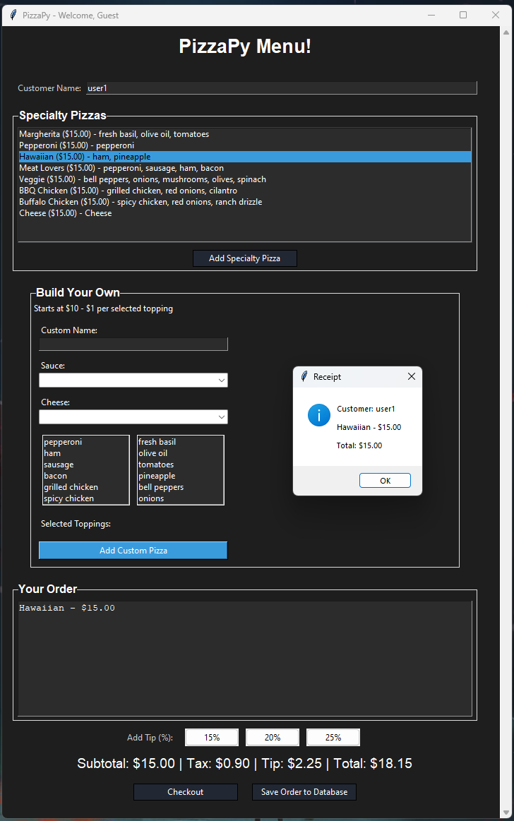

**Ordering a Meat Lovers pizza**

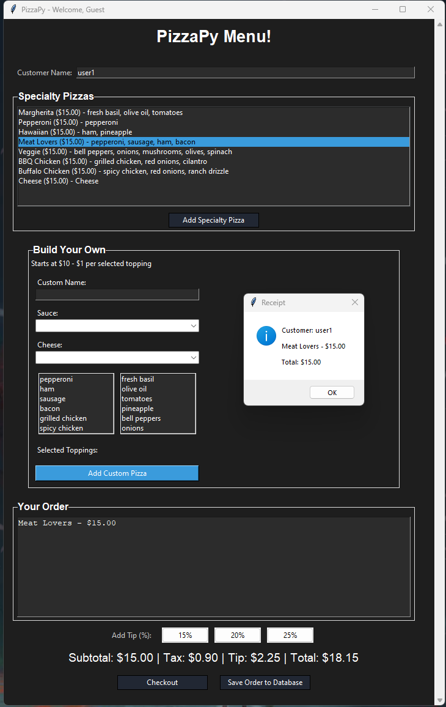

**Ordering a Veggie pizza**

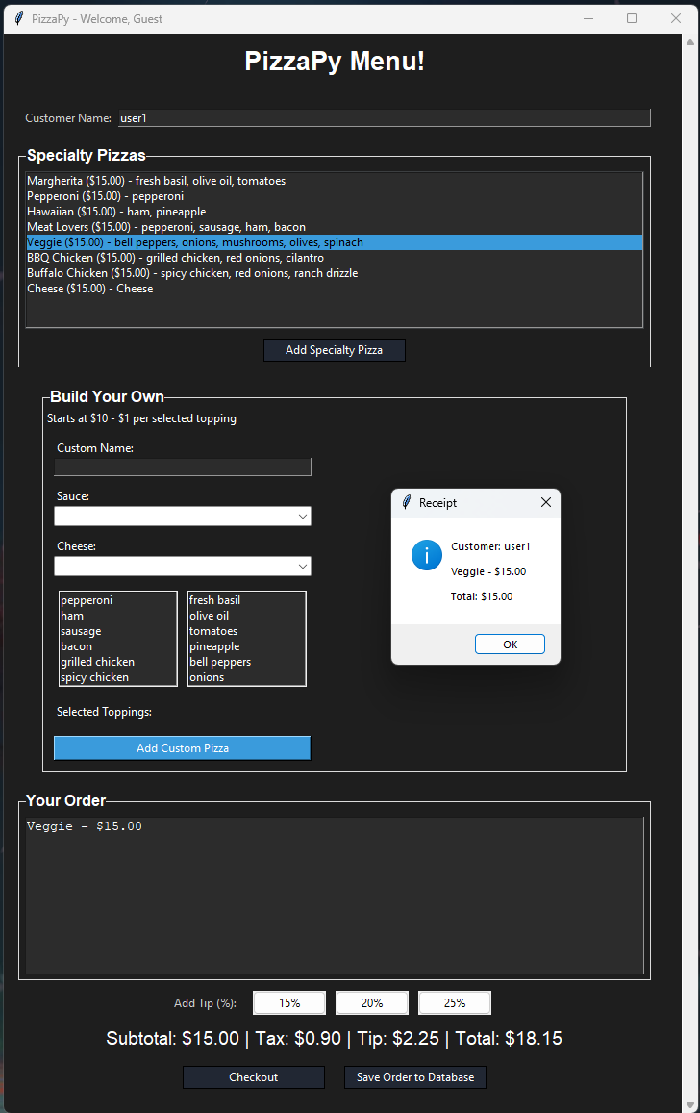

**Ordering a BBQ Chicken pizza**

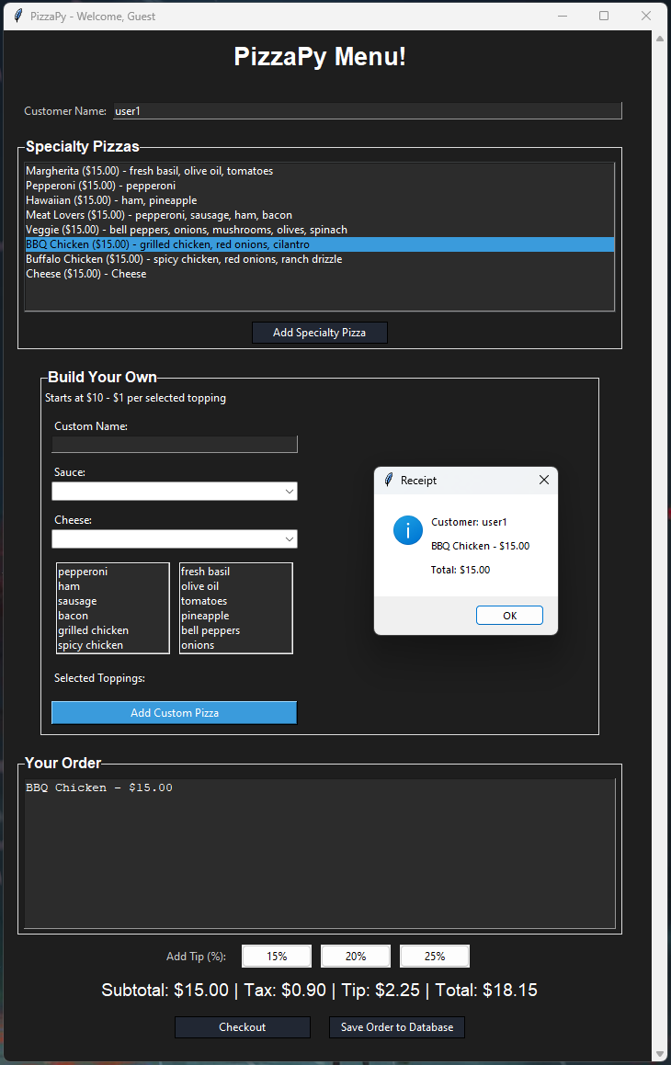

**Ordering a Buffalo Chicken pizza**

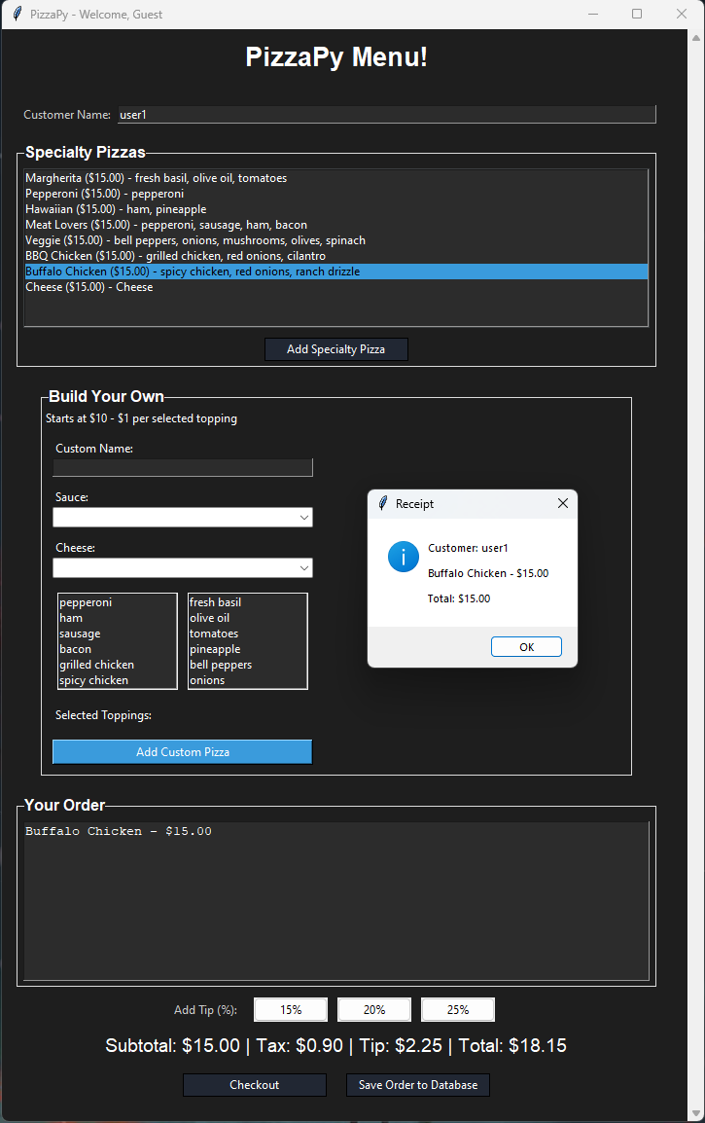

**Ordering a Cheese pizza**

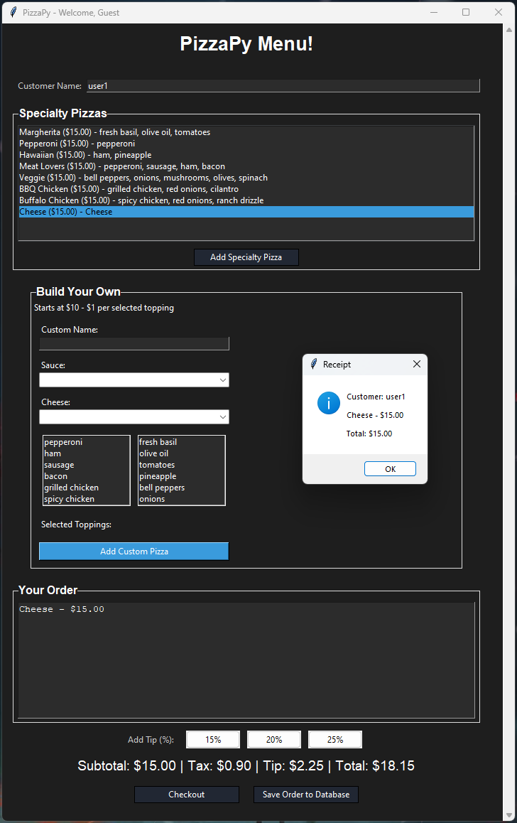

**Ordering a Custom pizza with tomato sauce, mozzarella cheese, pepperoni, bacon, fresh basil, tomatoes, and onions**

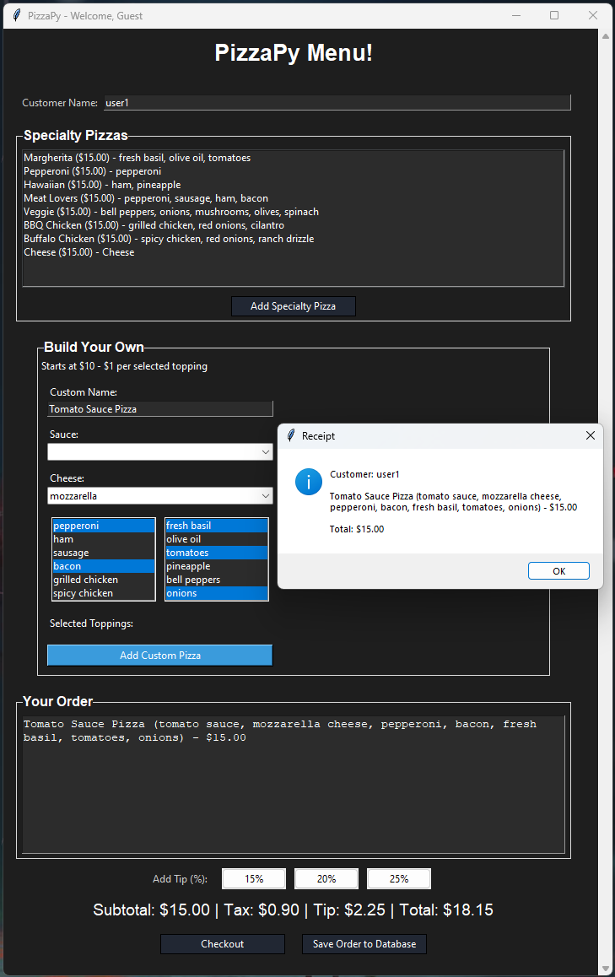

**Ordering a Custom pizza with bbq sauce, mozzarella slices, ham, sausage, and pineapple**

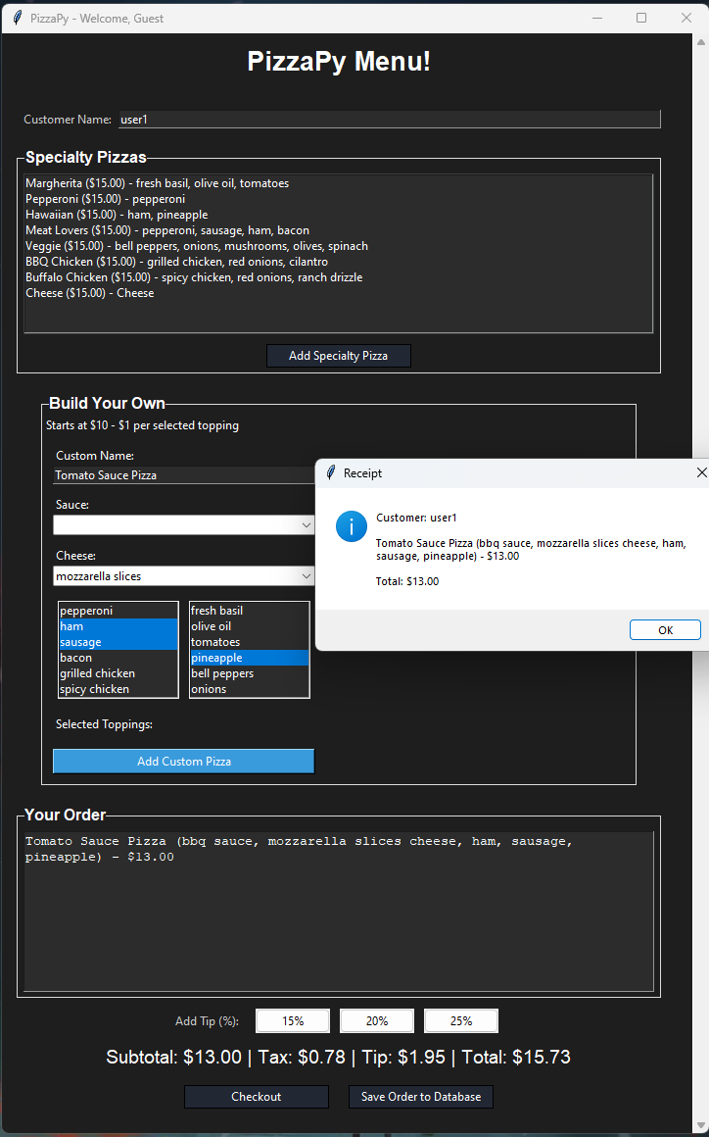

**Ordering a Custom pizza with buffalo sauce, mozzarella cheese, grilled chicken, spicy chicken, olive oil, and bell peppers**

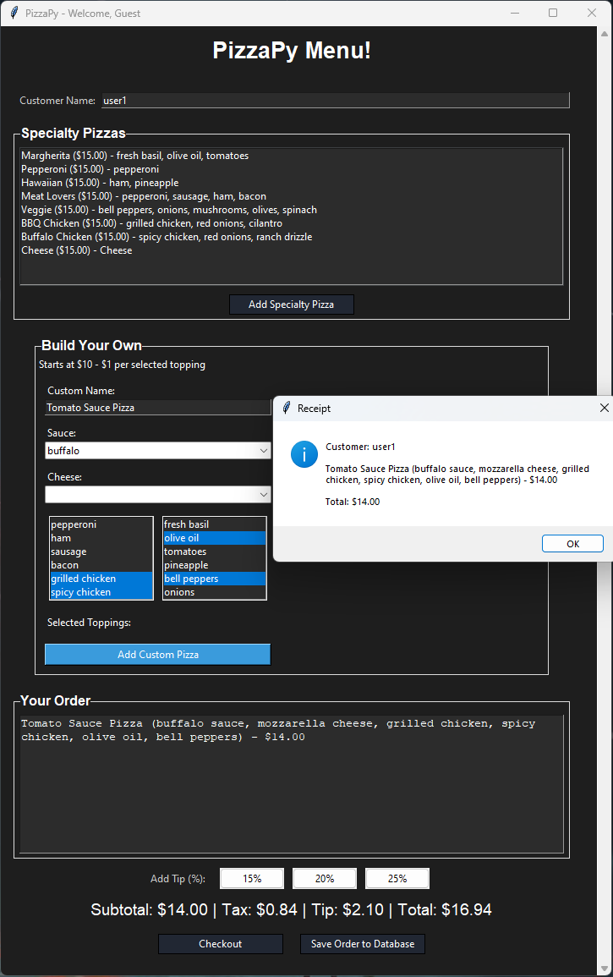

**If you attempt to order a Custom pizza without selecting any options, it will default to a tomato sauce pizza with mozzarella cheese**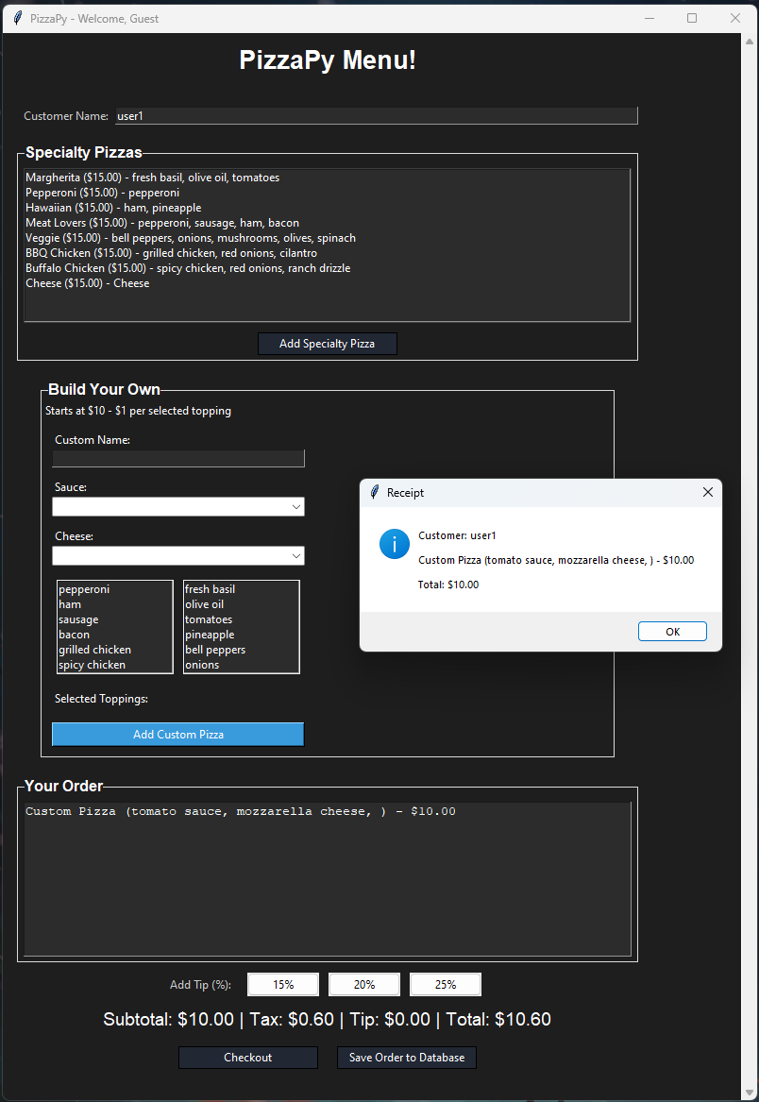

**Ordering a Pizza with a 15% added tip**

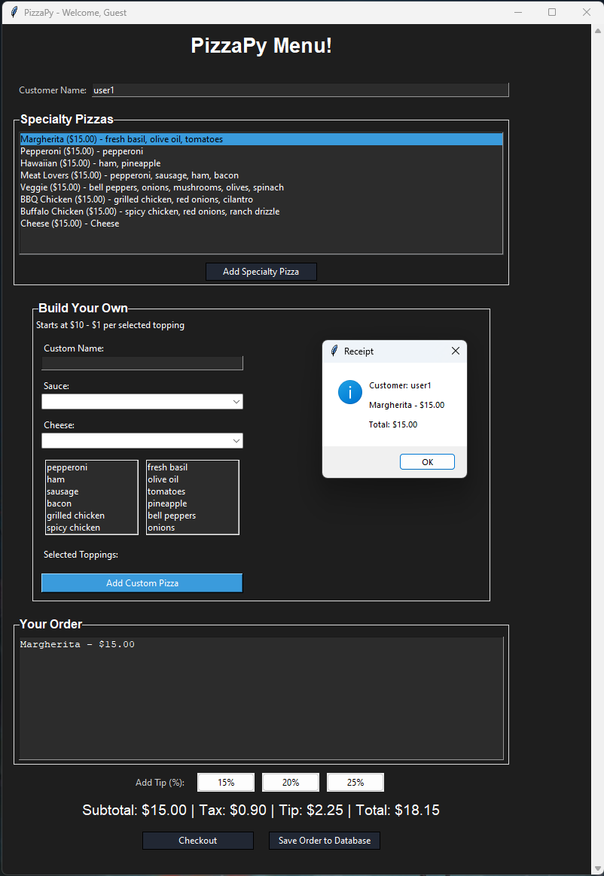

**Ordering a Pizza with a 20% added tip**

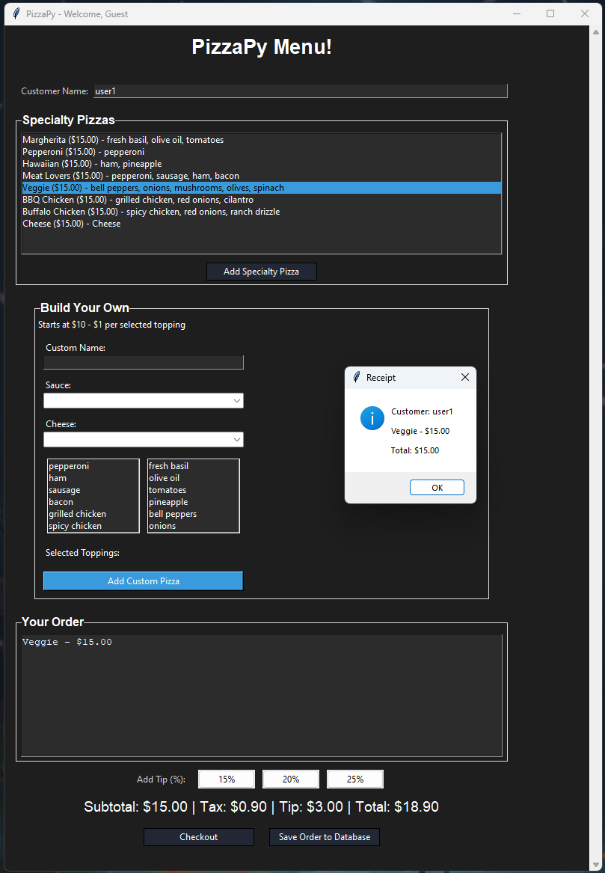

**Saving an order to the database**

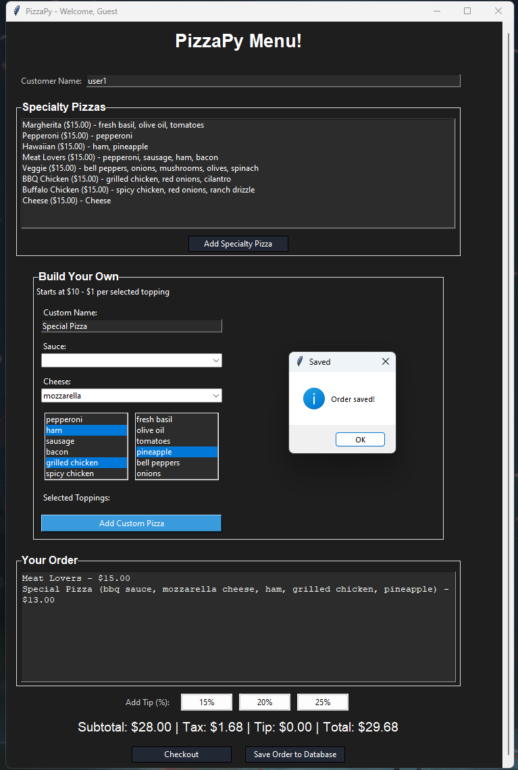

**Ordering a Pizza with a 25% added tip**

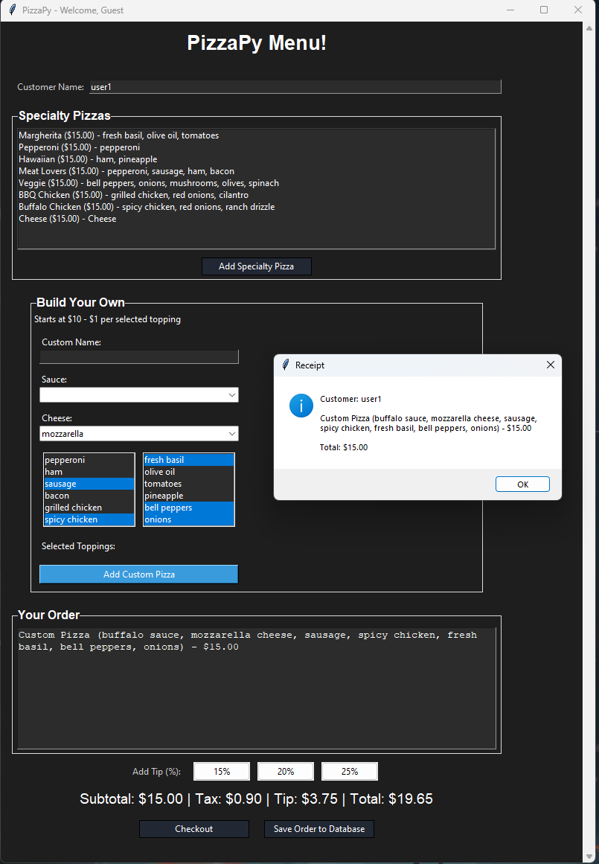

**Close look at the Receipt**

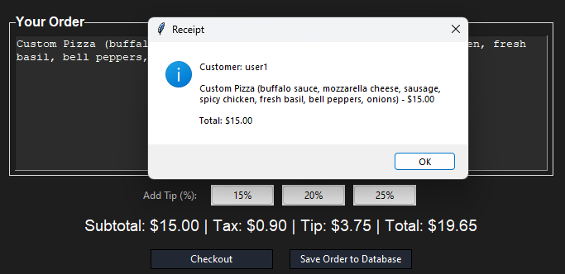

**Looking at the receipt, it looks like it is only outputting the subtotal and not adding the tax or tip. This is how it is for all combinations of ordering.**

1. **Conclusion**

**After the first round of testing, it has been discovered that most of the program is in working order. The login screen is working as intended. All the specialty pizzas are able to be ordered and are priced correctly. Every option in the custom pizza panel is able to be selected and the total is added up correctly for each ingredient. You are also able to save orders into the database. The only flaw that was found was on the receipt section. While we are able to see the customer and the order correctly, the total is not being added up as it should; we are seeing the subtotal instead of the total.**